NLP ASSIGNMENT

Q1:- Take a custom paragraph, perform the entire pipeline and Print results at each step.
Tokenization → Stopword Removal → Stemming → Lemmatization.
SOL:-
- Import Libraries
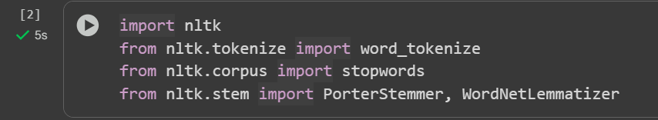

- Download required resources
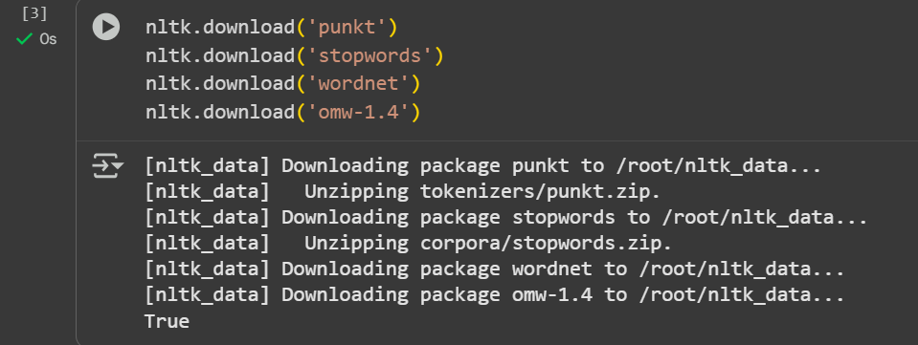

- Custom Paragraph
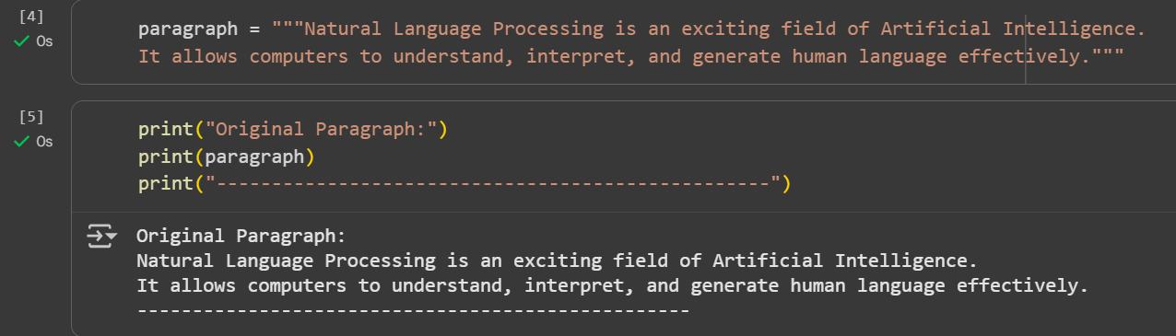

- Tokenization
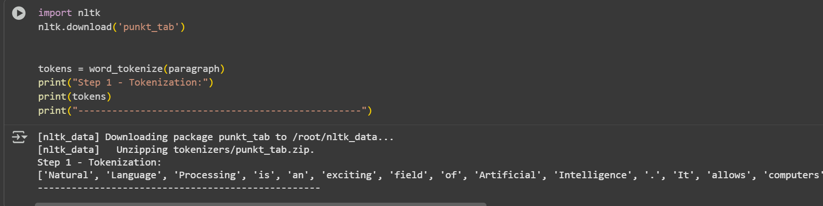

- StopWord Removal
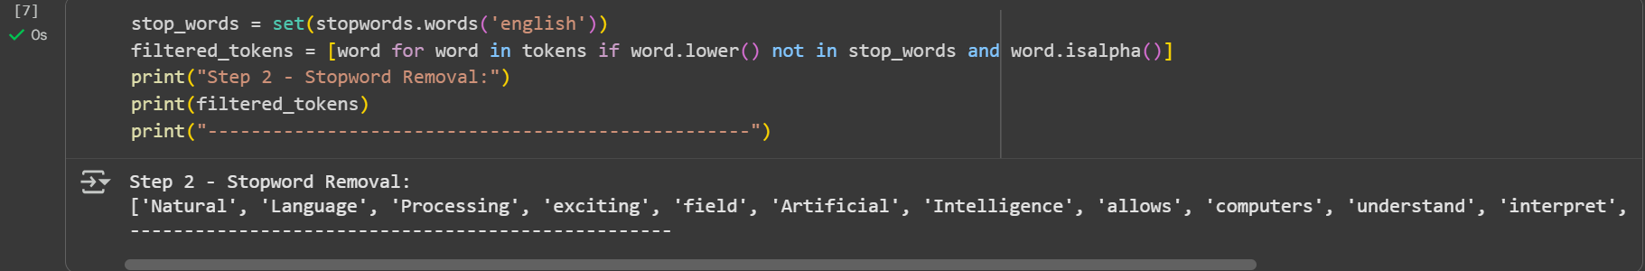

- Stemming
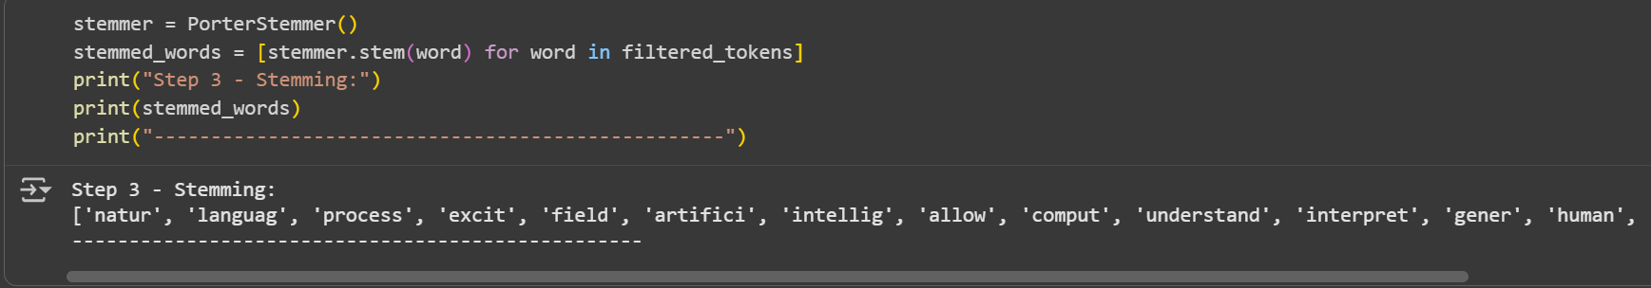

- Lemmatization
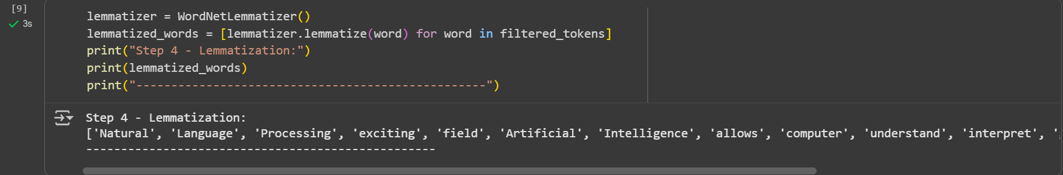

Q2:- Define NLP and its real time application in a specific domain base.
SOL:- Natural Language Processing (NLP) is a subfield of Artificial Intelligence (AI) and Linguistics that focuses on enabling computers to understand, interpret, and generate human languages in a meaningful way.
It combines computational linguistics, machine learning, and deep learning to process text and speech data.
Domain: Healthcare
In the healthcare domain, NLP plays a critical role in analyzing unstructured medical data and improving patient care.
Applications:
- Clinical Document Processing – NLP extracts key information (like symptoms, diagnosis, medications) from doctors’ notes, prescriptions, and electronic health records (EHR).
- Medical Chatbots & Virtual Assistants – Used for answering patient queries, scheduling appointments, or providing preliminary health advice.
- Disease Prediction & Risk Analysis – NLP Analyzes patient history and lab reports to detect early signs of diseases like diabetes, cancer, or heart conditions.
- Voice Recognition in Healthcare – Doctors can dictate notes, and NLP systems automatically convert them into structured medical records.
Example: IBM Watson Health uses NLP to read and interpret clinical research papers and patient data, helping doctors make faster and more accurate treatment decisions.
Q3:- What is NLU and NLG?
SOL:- NLU (Natural Language Understanding)
- Definition:
NLU is a subfield of NLP that focuses on enabling machines to understand the meaning, intent, and context behind human language.
- What it does:
  - Extracts entities (names, dates, locations).
  - Identifies intent (what the user wants).
  - Handles ambiguity, synonyms, and context.
- Example:
  - If a user types: “Book me a flight to Delhi tomorrow morning” →
NLU extracts:
    - Intent: Book flight
    - Entities: Destination = Delhi, Date = Tomorrow, Time = Morning
NLG (Natural Language Generation)
- Definition:
NLG is the opposite of NLU. It focuses on enabling machines to generate human-like text or speech from structured data or internal representations.
- What it does:
  - Converts data into meaningful sentences.
  - Creates reports, summaries, or conversational replies.
- Example:
  - Input data: {Destination: Delhi, Date: Tomorrow, Time: Morning}
  - NLG generates: “Your flight to Delhi is booked for tomorrow morning.”

